1. Given an array with n number of elements. Print all prime numbers from the given array.

Input: n=5, a=[10,20,11,20,13]

Output: 11,13

*public* *class* prime {

*public* *static* void main(String[] args) {

        int a[] = { 10, 20, 11, 20, 13 };

        for (int i = 0; i < a.length; i++) {

            System.out.println(a[i] + " " + isPrime(a[i]));

        }

    }

*public* *static* boolean isPrime(int n) {

        for (int i = 2; i < n; i++) {

            if (n % i == 0) {

                return false;

            }

        }

        return true;

    }

}

Output

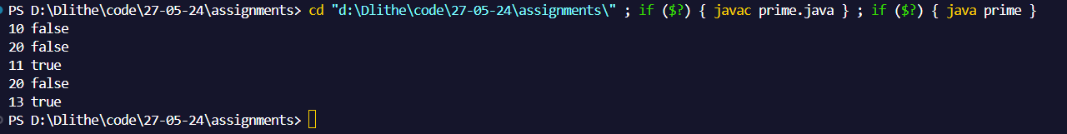

1. Given an array with n number of elements. Return true if sum of the digits of a prime number is again a prime number from the array. Else return false.

Input: n=5, a=[27,11,23,3,29]

Output: true.

* 11 is prime. The sum of digits 2. 2 is again prime.
* Just like, 23, 3 and 29 are primes. The sum of digits of these numbers are 5,3, 11 respectively. They are also prime.

*public* *class* addprime {

*public* *static* void main(String[] args) {

        int a[] = { 10, 20, 11, 20, 13, 23, 3, 29 };

        for (int i = 0; i < a.length; i++) {

            int sum = 0;

            int num = a[i];

            while (num != 0) {

                sum += num % 10;

                num /= 10;

            }

            System.out.println(a[i] + " " + (isPrime(a[i]) && isPrime(sum)));

        }

    }

*public* *static* boolean isPrime(int n) {

        for (int i = 2; i < n; i++) {

            if (n % i == 0) {

                return false;

            }

        }

        return true;

    }

}

Output

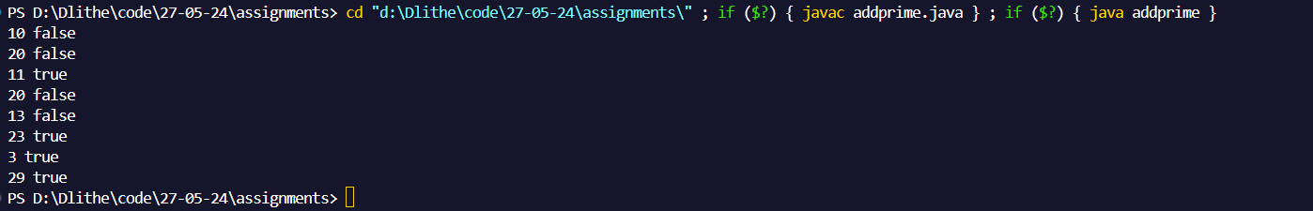

1. If the array contains any three continuous numbers, write a program to return true. Else return false.

input: n=5, a=[189,34,35,36,765]

output: true.

input: n=6, a=[189,304,5,6,765,7]

output: false

import *java.util.Scanner*;

*public* *class* continousnumbers {

*public* *static* void main(String[] args) {

        Scanner sc = new Scanner(System.in);

        System.out.print("Enter the size of the array : ");

        int n = sc.nextInt();

        int[] a = new int[n];

        System.out.print("Enter the elements of the array : ");

        for(int i = 0; i < n; i++){

            a[i] = sc.nextInt();

        }

        System.out.println(arrayelements(a));

    }

*public* *static* boolean arrayelements(int[] arr) {

        for (int i = 0; i < arr.length - 2; i++) {

            if (   (arr[i]+1 == arr[i+1])     &&    (arr[i+1]+1 == arr[i+2])   ) {

                return true;

            }

        }

        return false;

    }

}

Output

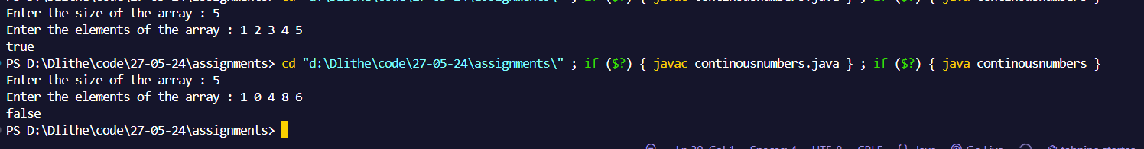

1. If the array contains any three continuous prime numbers, write a program to return true. Else return false.

input: n=5, a=[18,11,13,17,65]

output: true.

input: n=6, a=[3,5,6,765,7]

output: false

import *java.util.Scanner*;

*public* *class* continousprimenumbers {

*public* *static* void main(String[] args) {

        Scanner sc = new Scanner(System.in);

        System.out.print("Enter the size of the array : ");

        int n = sc.nextInt();

        int[] a = new int[n];

        System.out.print("Enter the elements of the array : ");

        for(int i = 0; i < n; i++){

            a[i] = sc.nextInt();

        }

        System.out.println(continuousprimes(a));

    }

*public* *static* boolean continuousprimes(int[] a) {

        for (int i = 0; i < a.length - 2; i++) {

            if (isPrime(a[i]) && isPrime(a[i + 1]) && isPrime(a[i + 2])) {

                return true;

            }

        }

        return false;

    }

*public* *static* boolean isPrime(int n) {

        for (int i = 2; i < n; i++) {

            if (n % i == 0) {

                return false;

            }

        }

        return true;

    }

}

Output

